**RDS setup**

**Optimize speed**

Load CFORM

Load RDS immediately

Indicate VPC

Load ELB

Load CloudFront

Do Launch Config

Do ASG

Do SG

Do NACL

Questions

Is there a way for me to secure my cloudfront better

AMI what is it

Information

1. Find out how to store application log files to a central location

2. Filter out the data

3. Find out how to send the data back to gameday server

Redis encryption at trest

Redis no need to add any other service

DataRT no need create new route

services

Lambda

Cloudwatch Logs Agents

Links for refund:

<https://docs.aws.amazon.com/AmazonCloudWatch/latest/logs/QuickStartEC2Instance.html>

<https://docs.aws.amazon.com/AmazonCloudWatch/latest/logs/AgentReference.html>

refund

create IAM role

configure cloudwatch logs agents

configure region

change file name

change group name

create lambda

stream aws lambda

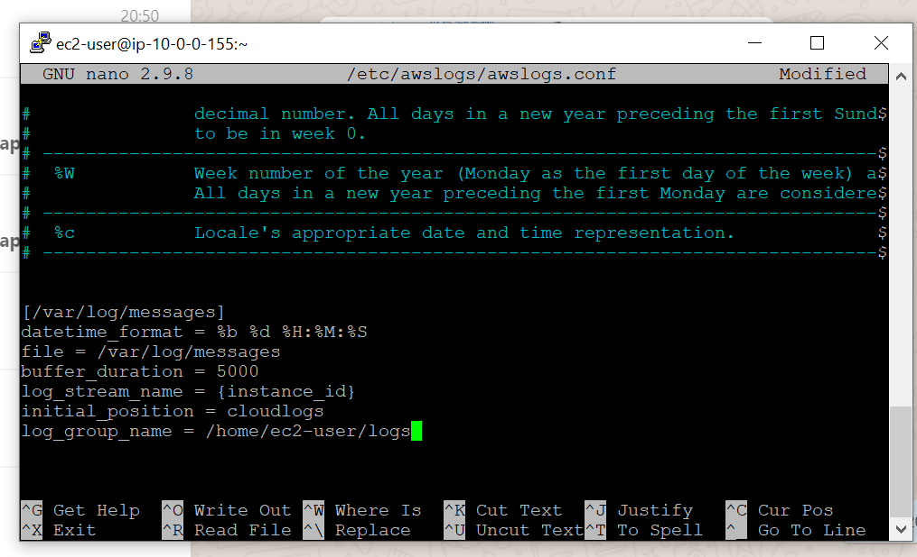

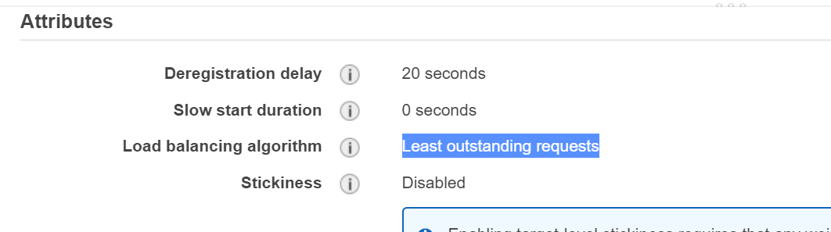

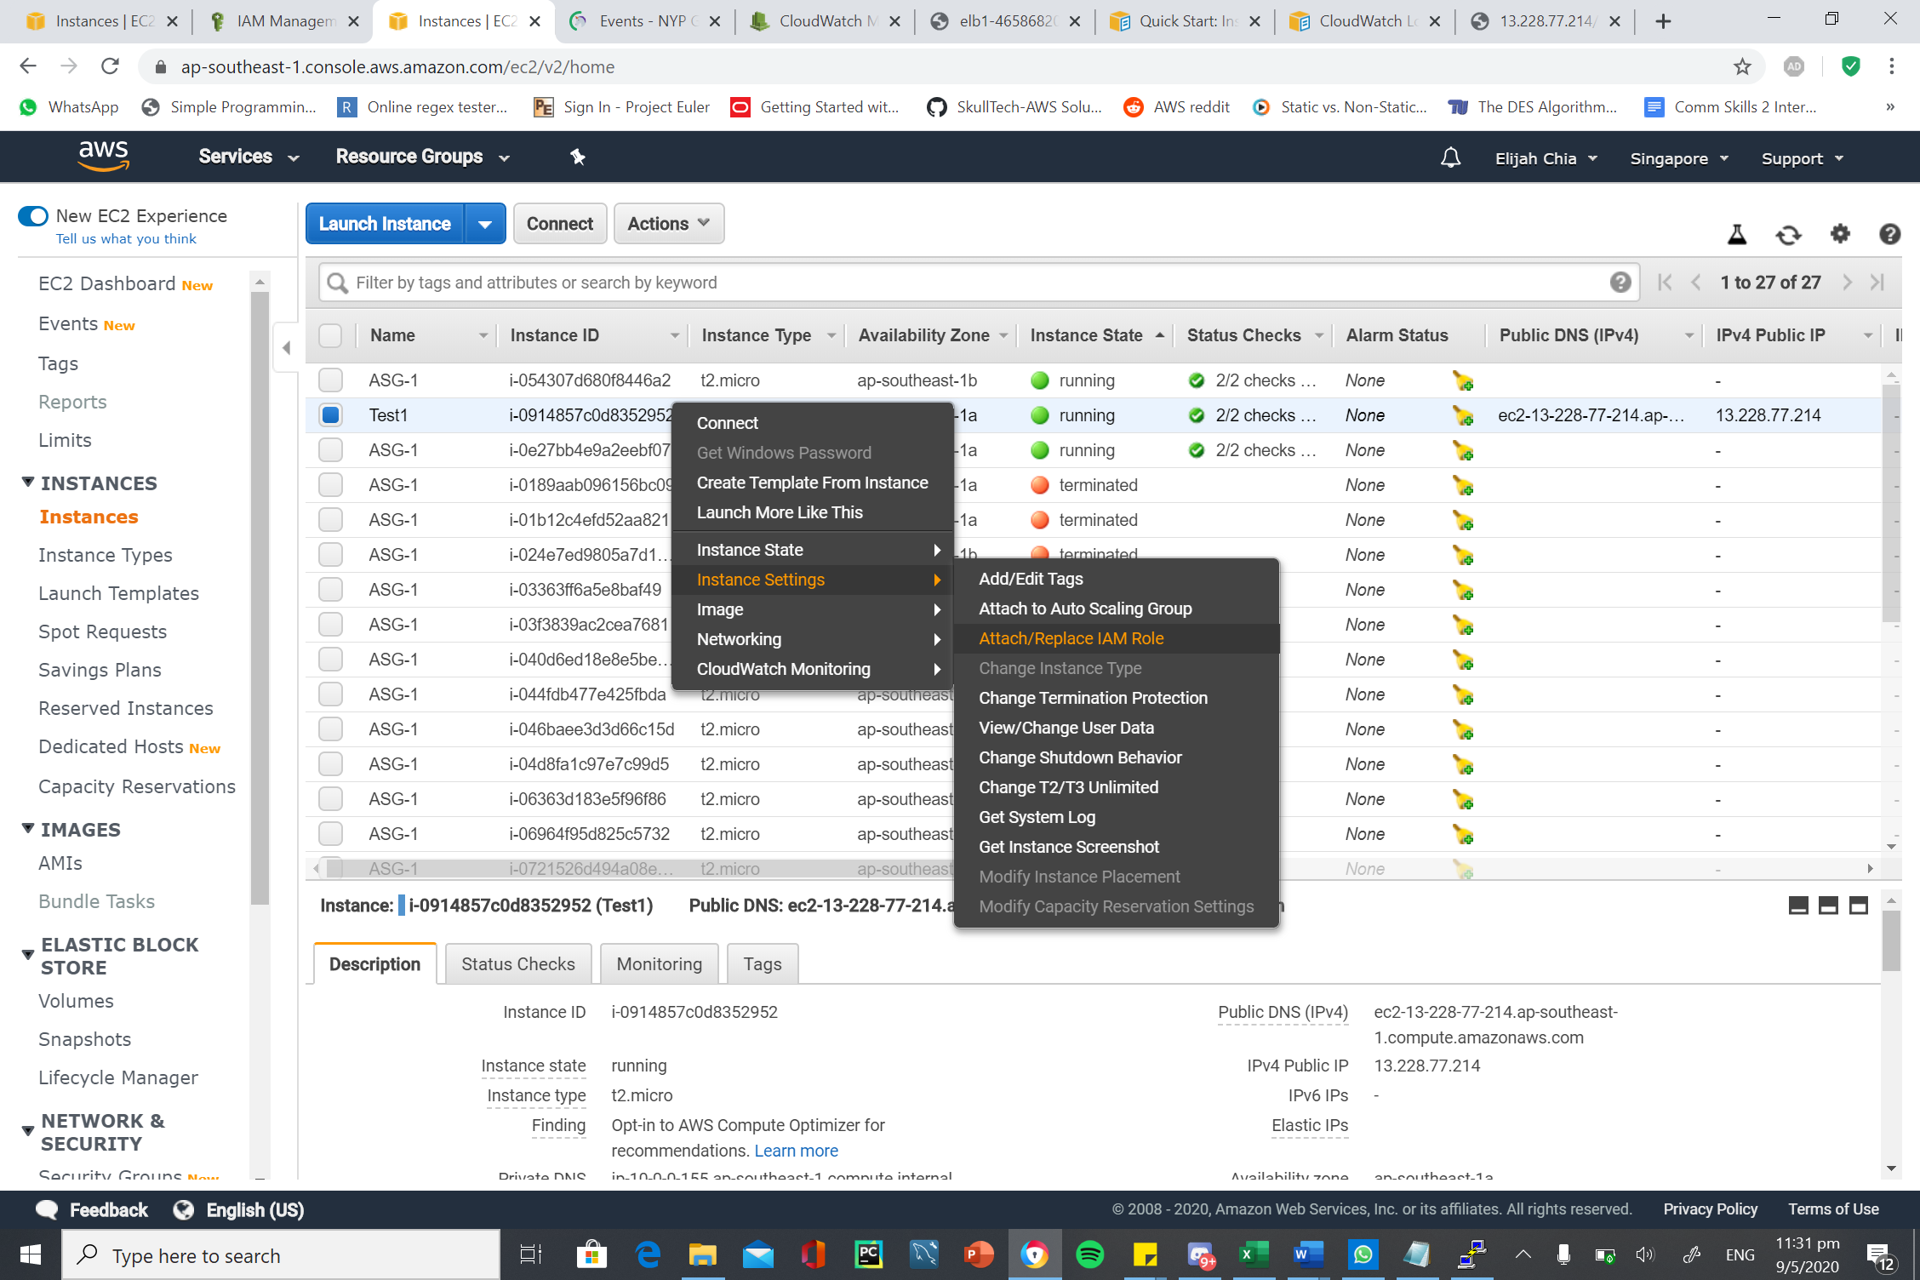

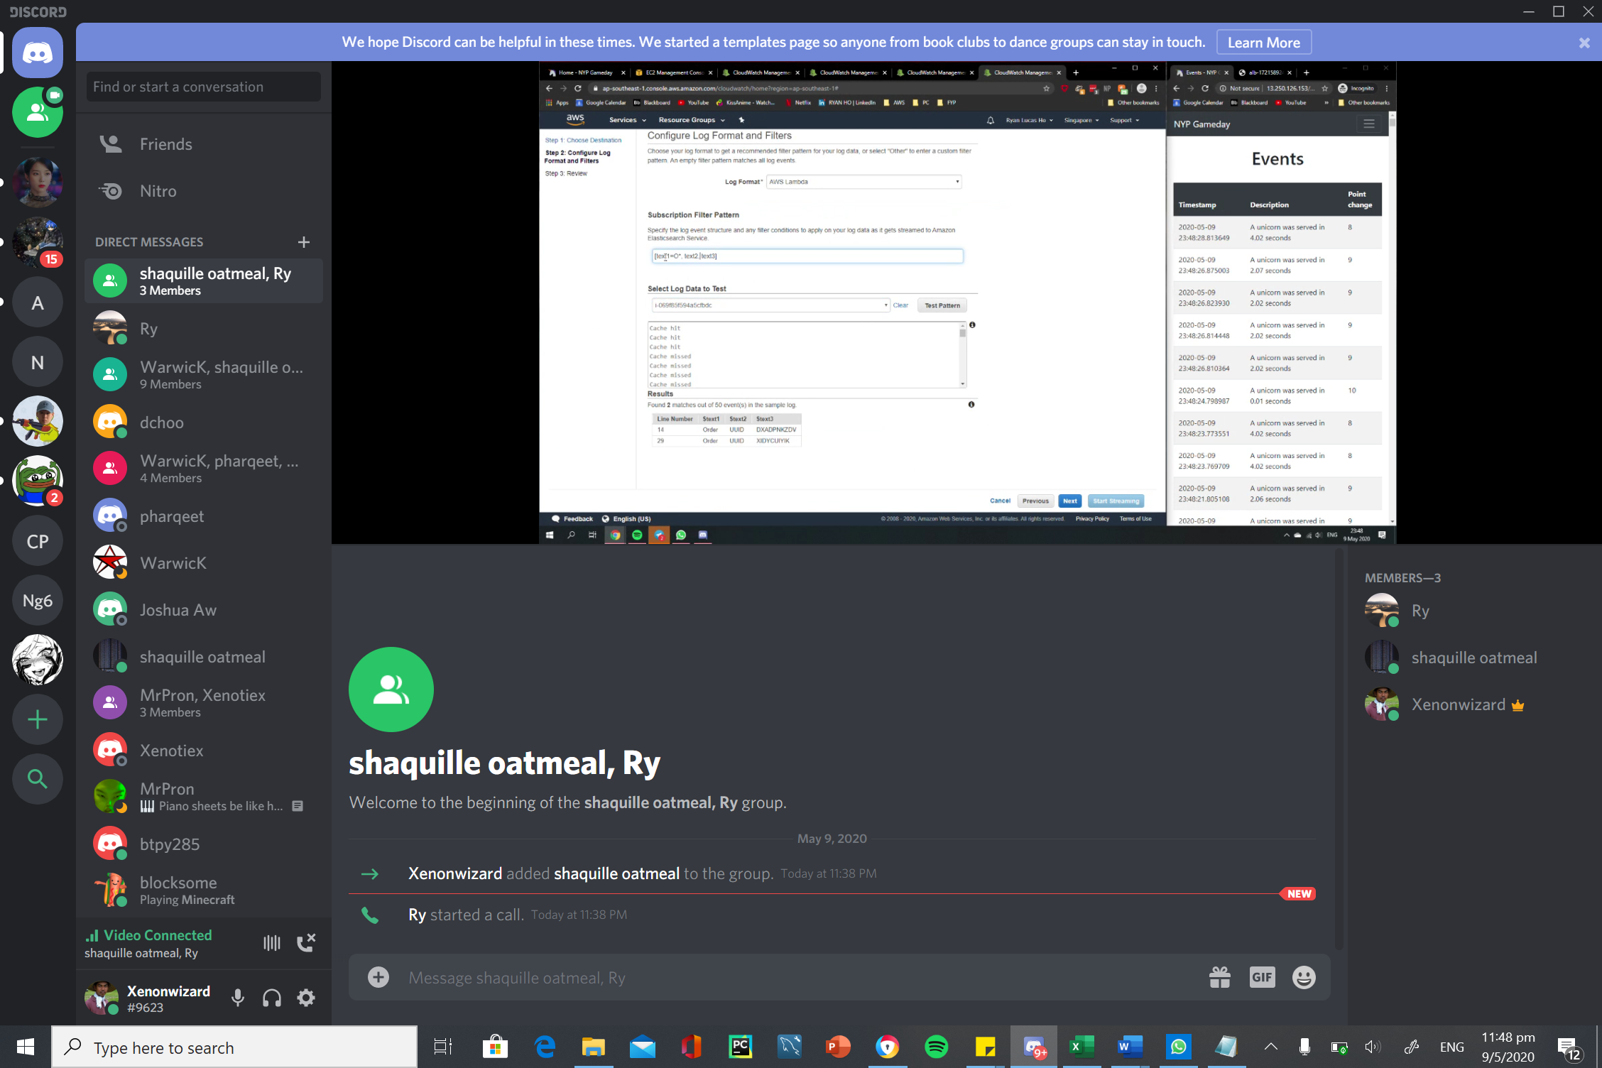

To do search through all the logs for the order for viewing.

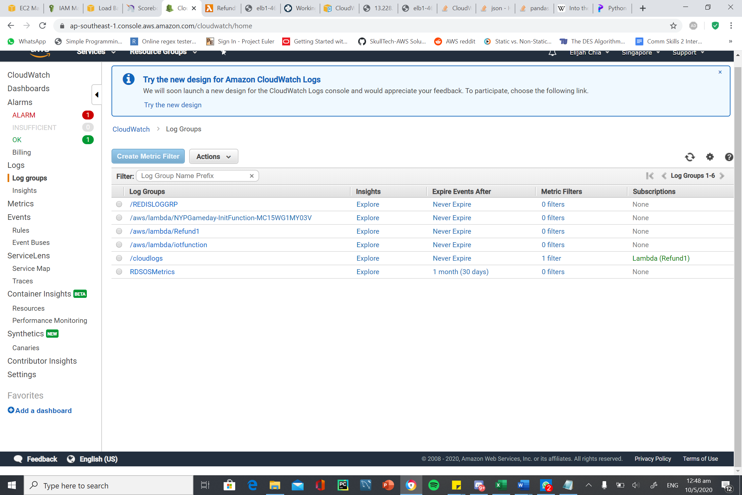

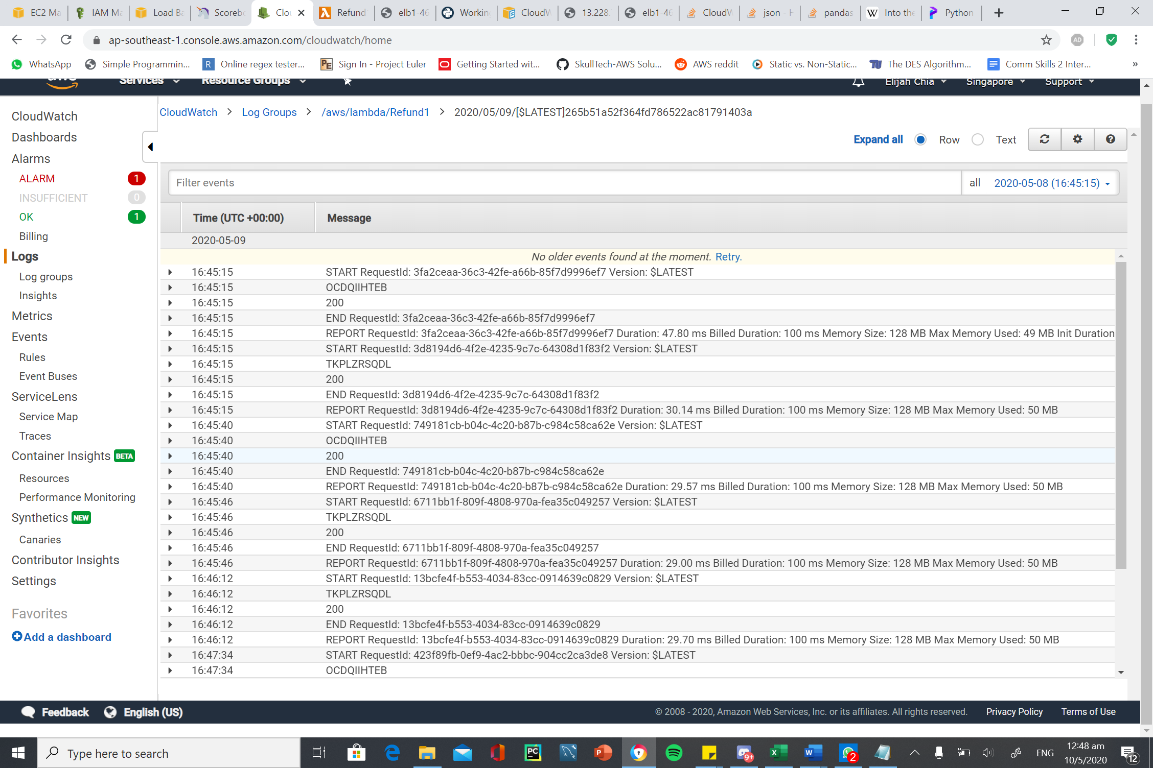

Try NACL

Try refund

Cloudfront whitelist

Metrics viewing easier

Target group health check

